**SEEP Intake**

Rapid Report to Share Early Findings

21st June 2019



**Introduction**

This report serves to inform SEEP interim about findings of the Intake Interviews of the 300 savings groups that have been interviewed in Mali and Uganda.

For this report we used a very straightforward format. We present the questionnaire that was administered. In the questionnaire we have pasted the graphs of the results for Mali and Uganda separately.

For each graph we write a short sentence summing up what can be concluded about the findings.

**Locations where the interviews took place**

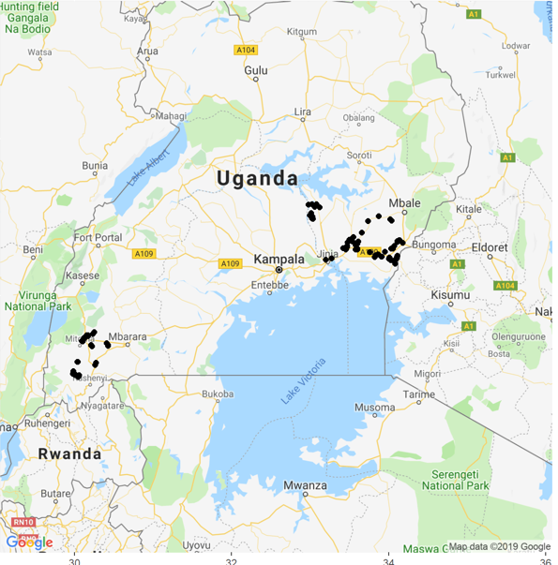

In Uganda the groups interviewed covered 9 districts. Four districts in Western Region named Rukungiri (Rukungiri District Farmers’ Association), Kanungu (KIRDP), Buhweju and Bushenyi (Aprocel). Five districts in Eastern Region named Kamuli (Recode), Iganga (3 researchers, Iganga District Farmers’ Association), Bugiri and Busia (SEPSPEL), Tororo (Community Vision).

Detailed views of the Uganda locations are below:

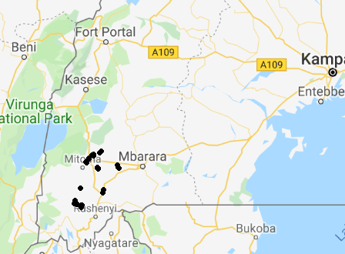

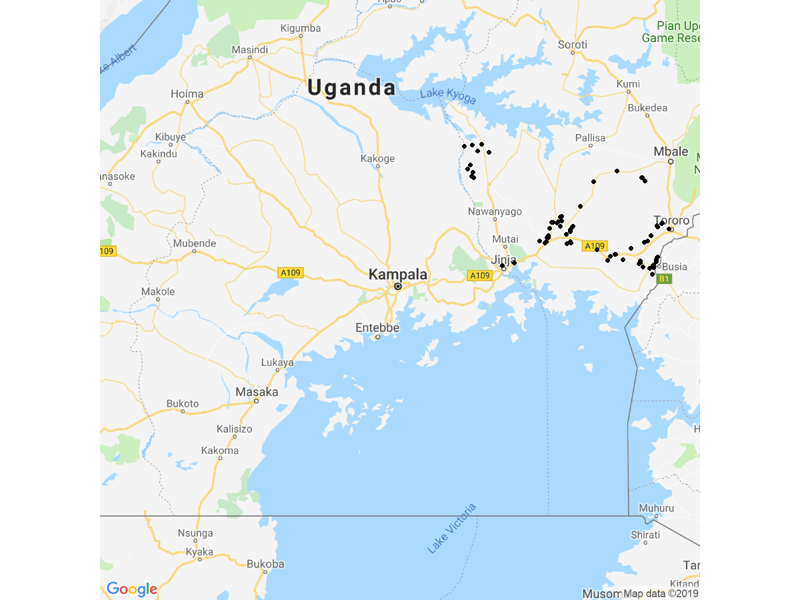

In Mali two circles named Bougouni (where the organisation CAEB was active) and Kalondieba (where the organisation J&D was active) are included. Within these cercles seven communes are included.

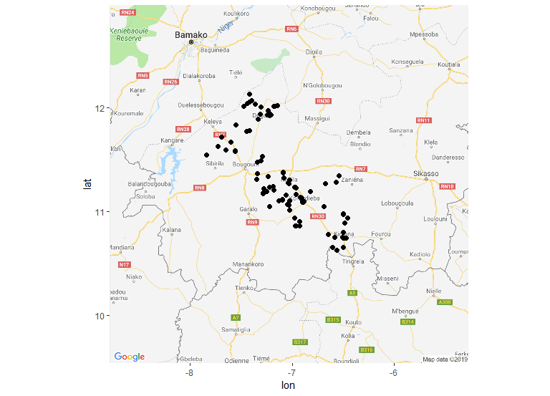

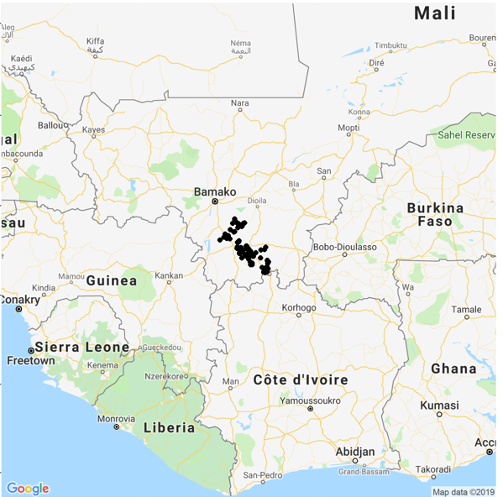

**Findings according to the questionnaire**

|  |  |  |
| --- | --- | --- |
| Question ID | Question | Answer |
| 1 | Greetings, my name is .... I am from L-IFT which is a company that does research about savings groups and VSLAs and the role savings groups have in members’ lives. This research will be used to help make VSLAs that will still be started better. I understand that you are part of the VSLA {0} . With your permission, I would like to visit your group for the coming three months so we can understand how you work, what you have learned, and if you have any challenges. I would like to start by asking you a few general questions about the group. This first interview takes about 15 minutes. |  |
| 2 | I will do my best to reduce the amount of time I ask from you, but your group will need to provide some information, and this will take some time. In exchange I hope the visits will be interesting for you and hopefully you will get some new awareness to help your group be even stronger. |  |
| 3 | This research is to learn what happened to the savings groups that were formed a long time ago. The research will interview 150 group in your country and another 150 groups in another country: Mali/Uganda. The research is very open-minded. It just wants to learn whether savings groups are still operating and how they are operating. There are no wrong or right answers. Do you allow me to interview you? We will be very careful with your information. It is confidential and we will not disclose to anybody what you said. We will only disclose for the entire research what all the respondents together said. Can I interview you now? Do you allow me to proceed? | Yes  No |
| 4 | The research will consist of 5 components: a. Census of savings groups (here we try to collect a full overview of existing groups in your village) b. Intake interview (that is this interview and it will last 15 minutes) c. Attending around 3 group-meetings over next 3 months (this will primarily be just observing the process of the meeting, without questions. At the end of the meeting I will have a few questions that will take 10 to 20 minutes and these questions are either asked to the group as a whole or to 1 or 2 individuals) d. Chairperson interview (this will take 30 to 45 minutes). e. Record keeper interview (this will take 30 to 45 minutes). This interview should take place with the person who maintains records. / MALI: I’d like to talk to the person who can best tell me how you keep records, how you know how much each person owes, and so on. |  |
| 5 | We are very careful that any information you give us remains confidential. We conduct the interview with each respondent privately and you and your group’s answers can never be traced back to you or your specific group. The information you provide will form part of a study of 300 VSLA groups in Mali and Uganda. If your group participates in the study I will bring the detailed information about confidentiality and a form to provide consent at my first visit to your group. |  |
| 6 | Do you have any questions about what I have just said? [....................] (leave the respondent some time to consider and ask you questions. She/he may want to consult other group members.) Will you allow me to conduct this first interview with you? Please note at the end of this first interview there are still questions in which you can indicate in case you need to think more and need to discuss with other group members whether to participate. Is it OK I proceed? | Yes, we can do the interview now  Yes, we can do the interview but I want to make an appointment for another time  I am not sure, please call me later  No, I and my group refuse to participate |
| 7 | When can we make an appointment to do this first interview, the intake interview? |  |
| 8 | Please also provide me your contact details and for someone else. What is your name and what is the name of the other contact person? |  |
|  | *Name 1st contact person* |  |
|  | *Name 2nd contact person* |  |
| 9 | Could I please have your contact phone number? And the contact phone number of the other contact person? |  |
|  | *1st contact number* |  |
|  | *2nd contact number* |  |
| 10 | So you are sure your group doesn’t want to participate? | Yes  No |
| 11 | Why doesn’t your group want to participate? | Don’t have time  Don’t know you  Don’t trust you  Group has problems  Group has secrets  Group isn’t really functioning now  Bad experiences with research/visitors  Other |
| 12 | Please receive my phone number. If you change your mind, you can always call me and we can still work together. Would you mind if I take your contact details, just to check on you later whether you are sure you don’t want to participate? If so, Please provide me with your contact details: name, telephone number, telephone number of someone else who can reach you |  |

**Verification**

|  |  |  |
| --- | --- | --- |
| Question ID | Question | Answer |
| 13 | Please help me verify the following information I have about your group |  |
| 14 | Name of group {0}, is this correct? | Yes  No, please specify what is the correct name’ |
| 15 | Region {0}, is this correct? | Yes  No, please specify what is the correct name’  I don't know |
| 16 | District {0}, is this correct? | Yes  No, please specify what is the correct name’  I don't know |
| 17 | Parish {0}, is this correct? | Yes  No, please specify what is the correct name’  I don't know |
| 18 | Village {0}, is this correct? | Yes  No, please specify what is the correct name’  I don't know |
| 19 | Group number {0}, is this correct? | Yes  No, please specify what is the correct number  I don't know |
| 20 | Date first training started {0}, is this correct? | Yes  No, please specify what is the correct date  I don't know |
| 21 | Number of members at group formation {0}, is this correct? | Yes  No, please specify what is the correct number  I don't know |
| Adm1.PNG | | |
| In Mali all groups started off with 30 members. In all groups there were originally 25 female and 5 male members, according to the administrative data.  Currently Mali has median group size of 24 members. Only 25 percent of the groups are larger than25 and 25 percent of the groups are smaller than 16.  In Uganda the groups were also all 30 on formation. There the distribution between male and female members varied. Median groups had 22 women members and 8 men members. Currently the groups in Uganda are median size 30 and only 25 percent below 30 in size. The groups appear to have grown on average with 25% being between 30 and 34 in size and another 25 percent larger than 34. Reportedly there is also one group with 200 members but that is not included in this graph (was assumed an outlier but it really is a verified group now). | | |
| 22 | Women members {0}, is this correct? | Yes  No, please specify what is the correct number  I don't know |
| 23 | Name of chairperson {0}, is this correct? | Yes  No, please specify what is the correct name’  I don't know |
| 24 | Trainer name {0}, is this correct? | Yes  No, please specify what is the correct name’  I don't know |
| 25 | The information I just listed to you about the group, name, chairperson, number of members, does this sound like your group or does it actually sound like another group? I know it is a long time ago but if you think the information is wrong, please tell me about it.” | Information is correct and sounds like my group  Most of the information is correct but some I don’t recognize  Information seems wrong, not from our group  other (specify) |
| int 25.PNG | | |
| In Uganda the vast majority of the groups confirm that they are the group that is on our list. Only in 6.5 percent of the cases the respondent of intake said that the group does not match with her / his group. (In these cases the groups were replaced). | | |
| int 25-1.PNG | | |
| In Mali all the groups confirmed that the information was correct and that they were the group that was on file. | | |

**Chapter 3**

|  |  |  |
| --- | --- | --- |
| Question ID | Question | Answer |
| 26 | How much was the fixed savings amount during first cycle? (Mali) |  |
| 27 | How much was the share amount during first cycle? (Uganda) |  |
| Int 26.PNG | | |
| Int 26-1.PNG | | |
| In Mali the fixed savings amount was median 100 CFA (about 0.17USD at current exchange rate). This was the value of the fixed savings amount at first cycle for more than half the intake groups. About one-third of the groups had larger fixed savings amount per member. About 8 percent had 200 CFA fixed savings amount and about 10 percent 250 CFA. Only a handful of groups started off with a larger fixed savings amount. | | |
| int 27.PNG | | |
| int 27 -1.PNG | | |
| In Uganda the median share amount was 1000 UGX (around 0.27 USD at current exchange rate). However, since one member can save up to five shares, the savings amounts in Uganda were substantially higher when starting than Mali. About 30 percent of the groups had 500 UGX as starting share value, and about 10 percent had 2000 UGX as share value and a handful higher share value, 2 groups of 2500 UGX and about 8 groups of 5000 UGX. | | |
| 28 | How often did the group meet in the first cycle? | Weekly  Every 2 weeks  Monthly  It is not regular  Other (specify)  I don’t know |
| int 28.PNG | | |
| In Uganda, the vast majority of the groups met weekly during their first cycle. In total only 2.6 percent met at a different frequency. 1.3 percent every 2 weeks, 0.6 percent monthly and 0.6 percent ‘other’. | | |
| int 28-1.PNG | | |
| In Mali also the vast majority of the groups met weekly during their first cycle. Only 4.9 percent met at a different frequency. Of these 3.1 percent met monthly and 1.8 percent every two weeks. | | |
| 29 | Where does the group meet nowadays? |  |
| 30 | Can you please bring me to the place of the group meeting? | Yes, we moved to the group meeting place  No, we did not move there |
| 31 | When was the last group-meeting? | I don't know |
|  | | |
| The graphs compare in days the amount of time that had elapsed from the day of the interview since the last group meeting was held.For both Mali and Uganda, the median amount of days is less than a week since they had held their last meeting. | | |
| 32 | At what time was the last group meeting held? | I don't know |
| 33 | When do you expect the next group meeting to take place? |  |
|  | | |
| Th groups were also asked when the next meeting would be. The mdedian time in days for Mali was 3 days while for Uganda it was four days.Most respondents gave between one and six days for both countries. | | |
| 34 | How often does your group meet? | Daily  Weekly  Every 2 weeks  Monthly  It is not regular  Other (specify)  I don’t know |
|  | | |
| In Both Mali and Uganda,the majority of respondents indiated that the group met weekly. This is 89% in Uganda and 95% in Mali. | | |
| 35 | Are there months when the group is meeting more? Which ones? | January  February  March  April  May  June  July  August  September  October  November  December  We meet on regular intervals on every month |
|  | | |
| In Uganda,67% of the groups met regularly each month with some meeting more in september)7%( August.InMali, tMost groups met regularly each month ( but there weresome groups that met more between January and July. | | |
| 36 | Are there months when the group is meeting less? Which ones? | January  February  March  April  May  June  July  August  September  October  November  December  We meet on regular intervals on every month |
|  | | |
| In Mali,most groups ndicated that they met regularly but there were some groups that indicated that they met less between July and December. 65% of Ugandan groups indicated that they met regularly each month byt some groups indicated that they met less between january and May. | | |
| 37 | At what time of the day does the group meet? | It is not a fixed time  I don’t know |
|  | | |
| In Mali, most groups meet in the morning hours between 8-9 Am while in Uganda there is more diversity in meeting time. Most of the groups however meet in the morning hours with the median meeting time being 2PM. | | |
| 38 | How many group members does the group have at the moment? | I don't know |
| 39 | How many of the members are female / how many are male? |  |
|  | *Female* |  |
|  | *Male* |  |
|  | | |
| In Mali, there are very few men in the groups with a majority having between 18 to 25 members. In Uganda, there are more men in the groups than in Mali, however, women are still the maority with a median of 30 members. In Uganda, there are afew groups with more members with a maximum of 200 members in Uganda while in Mali all groups have less than fifty members. | | |
| 40 | What savings obligations do group-members have? |  |
|  | *They all save exactly the same amount* | *Yes*  *No*  *I don't know* |
|  | *All group members save the same amount, but some group members have double or triple membership, so they save twice or thrice the normal amount* | *Yes*  *No*  *I don't know* |
|  | *They save in shares, with minimum 1 share and maximum 5 shares* | *Yes*  *No*  *I don't know* |
|  | *They save in shares, no minimum, maximum 5 shares* | *Yes*  *No*  *I don't know* |
|  | *They save in shares, but other rules apply (specify rules)* | *Yes*  *No*  *I don't know* |
|  | *Other (specify the diverging savings obligation)* | *Yes*  *No*  *I don't know* |
|  | | |
| *IN Mali a majority of groups have the same savings obligations for their members. In Uganda most people save in shares .* | | |
| 41 | In between meetings, where does the group keep its cash? | A box, bag or similar without locks  A lock-box, bag with 1 lock  A lock-box, bag with 2, 3 or more locks  No specified place, held by the treasurer or other group-member  Mobile money  Formal financial service provider (bank, MFI, credit union...  Other (specified)  We won’t tell you.  I don't know |
|  | | |
| In Uganda, the groups keep money in more secure boxes and with about 15% keeping money either in the bank or in mobie money.In mali 82% keep their money in boxes with 1 lock and the rest in boxes with 2 locks and very few in boxes without locks. | | |
| 42 | Can group members take loans from the savings held by the group? | Yes  No  I don’t know |
|  | | |
| Most of the groups in Uganda allow members to take loans:98.7% while in Mali all groups that were analyzed allowed members to take loans. | | |
| 43 | What rules apply for being eligible for a loan? |  |
|  | *Attendance of group meetings* | *Yes*  *No*  *I don't know* |
|  | *Members can take a loan worth 3x their savings* | *Yes*  *No*  *I don't know* |
|  | *Other minimum savings criteria* | *Yes*  *No*  *I don't know* |
|  | *Have a sound plan what to do with the money* | *Yes*  *No*  *I don't know* |
|  | *Invest the money in business* | *Yes*  *No*  *I don't know* |
|  | *Other (specify)* | *Yes*  *No*  *I don't know* |
|  | | |
| In mali attendance of group meetings is the main rule applied for eligibility for loans followed byamount of savings and reason for taking the loan. In Uganda, the amount that one has save as well as the purpose of the loan are the main rules that apply although meeting attendace was also very important. | | |
| 44 | What is the maximum loan period? | One month  2-3 months  4-6 months  More than 6 months Variable, depending on amount, purpose, season or other factors  Other (specify)  I don’t know |
|  | | |
| In Uganda, most loans have a repayment period of 2-3 months,in Mali most loans are over 6 months.Uganda has a preference for shorter loan repayment period but a longer one is een in mali,with loans of above two months taking the majority percentage of over 65%. | | |
| 45 | What is the interest rate charged by the group? Indicate the interest rate as a percentage. | Other  I don’t know |
|  | | |
| In Mali a majority of groups charge 10% with very little variability for Mali. In uganda also most groups charge 10% for the loans but there are a significant group that charges less than ten percent,specifically 5% . | | |
| 46 | How is the interest calculated/applied? | Charged one time, on the loan amount  Charged each month, on the loan amount  Charged each month, on the balance of the loan  Other (specify)  I don’t know |
|  | | |
| In Mali and Uganda most groups charge their loans each month. 37% in Mali charge 1 time, and 14.1 in Uganda do the same. Some groups charge the loans monthly on the loan balance mostly in Uganda:38% and 5% in Mali. | | |
| 47 | What do you think about the amount of money available for loans? | There are always more people interested to take a loan than the available loan funds  There are sometimes more loan applications than available loan funds  There is always more available loan funds than the demand for loans  It varies, sometimes more funds, sometimes more loan applications  Other (specify)  I don’t know |
|  | | |
| In both Uganda and Mali, there are always more people interested in loans than the available funds for most groups. The situation does vary with with some groups having more money than demand for loand and others having both situation dependng with situation. | | |
| 48 | If there is cash left over at the end of a meeting, what happens? | The money stays in the group until next meeting  Members are obligated to borrow the money  The funds are deposited in a (bank-)account  Other (specify)  This situation has never happened  I don’t know |
|  | | |
| In Uganda most of the cash that remains after the meeting stays within the group.the rest are either deposited in the Bank or borrowed by the members. For Mali the money is mostly kept within the group until the next meeting. | | |
| 49 | Who is currently the chairperson? |  |
| 50 | What is the chairperson’s gender? | Female  Male  undefined  I don’t know |
|  | | |
| All the respondents in Mali indicated that the Chairpersons in their respective groups were females.IN uganda, the female gender represented 56% of the chairpersons in their groups with the rest being male. | | |
| 51 | Could you please give me the chairperson’s phone number? | I don't know  Does not have a phone number |
| 52 | What is the gender of the respondent? | Female  Male |
|  | | |
| In both Mali and Uganda, females were the main respondents with mali having the largest female representation among respondents: 96% with Uganda having 64%.Men were approximately 35% in Uganda while in Mali 4%. | | |
| 53 | Please estimate the age of the respondent and write in years? | I don't know |
|  | | |
| The estaimated respondent age had a median of49 years in Mali and 48 in Uganda. The lowest age lrecorded was 20 years for both countries but Uganda had more variability in age with a maximum of 86years recorded wile the maximum age for Mali was70 years. | | |

**GPS**

|  |  |  |
| --- | --- | --- |
| Question ID | Question | Answer |
| 54 | GPS captured until now: {0} |  |
| 55 | GPS coordinates were recorded: Long: {0} Lat: {1} You can now safely finish the survey. |  |